­Name: Do Hyun Hwang

Class: CS547/IE534

netID:hwang101

Homework 4 Resnet

In this homework assignment, we were told to implement various resnet architecture for three datasets: CiFAR100, Tiny Imagenet, and Imagenet. Here are more specific goals outlined for the homework assignment.

1. Implement Resnet as specified in the homework direction from scratch using Pytorch on CiFAR100
2. Implement Resnet from scratch using Pytorch on Tiny ImageNet.
3. Implement Resnet by setting up synchronous learning from Blue Waters on CiFAR100.
4. Implement Resnet by loading a pre-trained model on ImageNet.

***Implementing ResNet from Scratch using PyTorch on CiFAR100***

We were given a strict architecture to follow for the first task. The architecture for this specific ResNet is given below:

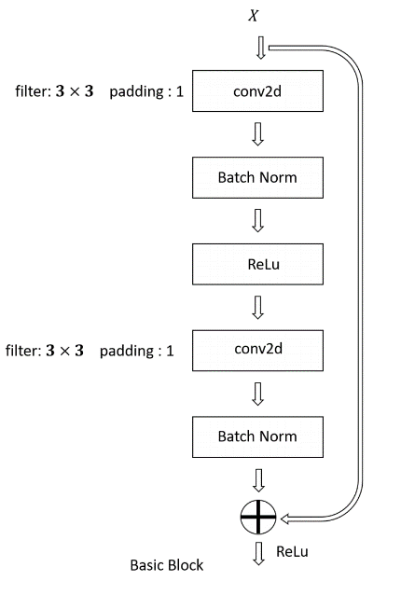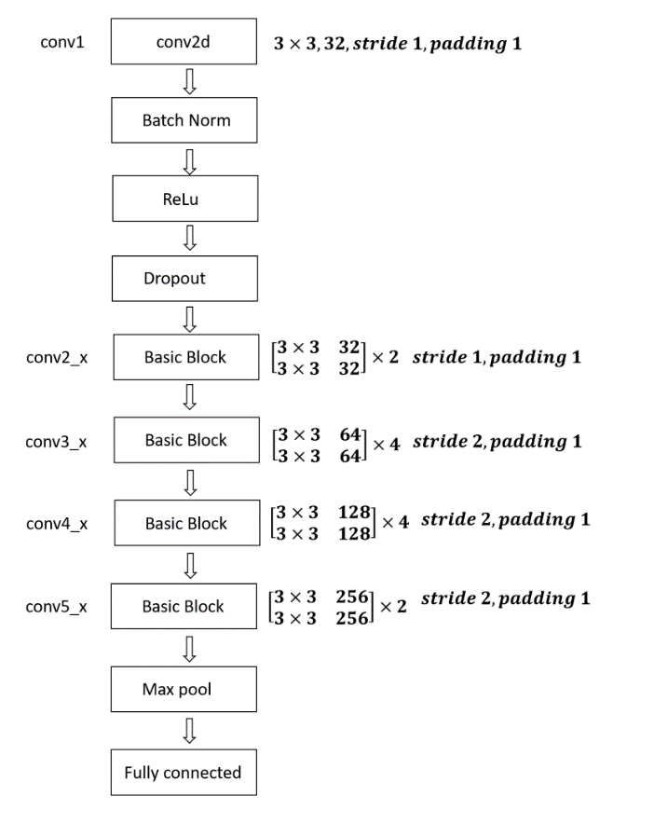

On top of the architecture, I have implemented some data augmentations to create some variance within the training sets.

*LIST AUGMENTATIONS HERE:*

Results: After about 20th epoch, I was able to achieve the targeted accuracy.

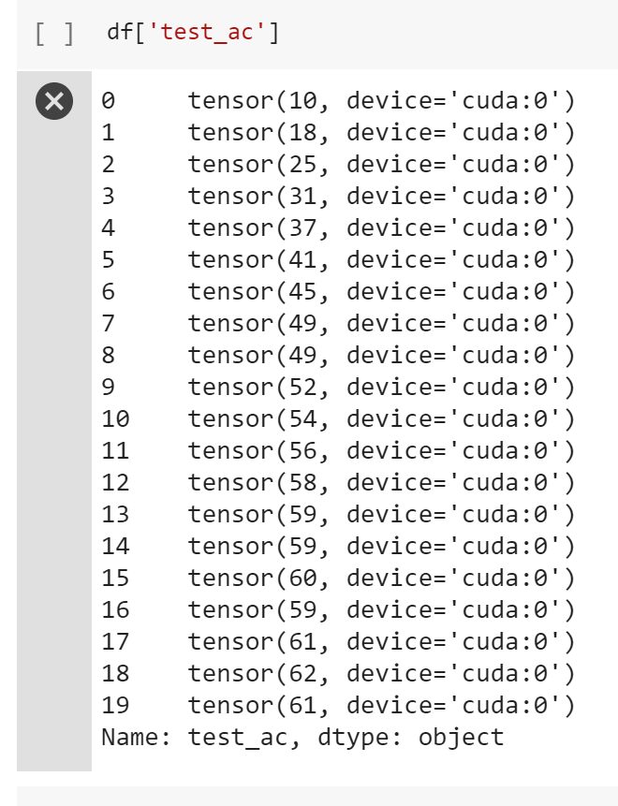

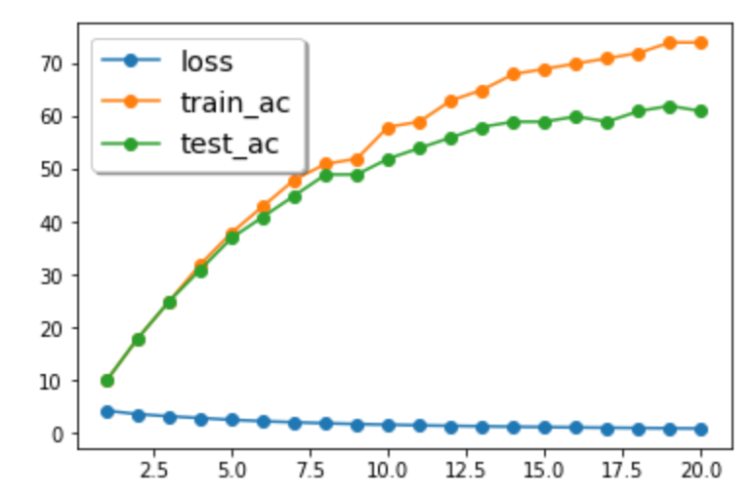

***Implementing ResNet from Scratch using PyTorch on Tiny ImageNet***

***Implementing Resnet from Pretrained Model***

PyTorch has pretrained ResNet18 model available to download and use. I downloaded the model and trained CiFAR100 on it. Since the model is trained on ImageNet which has a resolution of 224 x 224, I had to use





Sync



